**Building a ABBC container with Docker(Ubuntu 18.04)**

Installation

First, we will need to make sure that we have the latest Docker CE installed.

$ curl -fsSL <https://download.docker.com/linux/ubuntu/gpg> | sudo apt-key add –

$ sudo add-apt-repository "deb [arch=amd64] <https://download.docker.com/linux/ubuntu> xenial stable"

We can then install docker from there and make sure that it is started at boot time using

$ sudo apt-get update

$ sudo apt-get install docker-ce

$ sudo systemctl enable docker

Now Save the ABBC File in Ubuntu server.

Go to the files folder and run these commands

sudo docker build -f Dockerfile.dev -t abbc-dev .

sudo docker build -f Dockerfile.build -t abbc-ubuntu-build .

sudo docker build -f Dockerfile.install -t abbc-ubuntu-bin .

Let us now test our installation. We first bring up an instance of our new container.

sudo docker run -it abbc-ubuntu-bin

cd /abbc-master/src

ls

You will see result like this

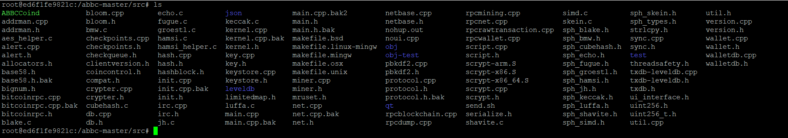

open the second terminal .

sudo docker container ls

you will see the container is contacted .

C:\Users\ovs_m\Desktop\container_conected.PNG

Now : - > Open the **first termina**l and we can now run the ABBC daemon.

so go to abbc-master / src

and run -> ./ABBCCoind

then we have to copy the ABBCCoin.conf to our container

**Then :- > Open second** terminal and open the directory where ABBCCoin.conf is save and run

sudo docker container ls

C:\Users\ovs_m\Desktop\container_conected.PNG

you will see your container Id copy container id And run

sudo docker cp /[PATH of ABBCCoin.conf file] [containerid]:/root/.ABBCCoin/

then open **First terminal** which is contacted to your container .

then cd /root/.ABBCCoin

type ls you will see the ABBCCoin.conf file



Then Again go to abbc-master

Run cd abbc-master/src

Run ./ABBCCoind

Once the daemon has started, we can verify that it is up and running and ready to accept commands RUN -> ./ABBCCoind getinfo

You will see this result

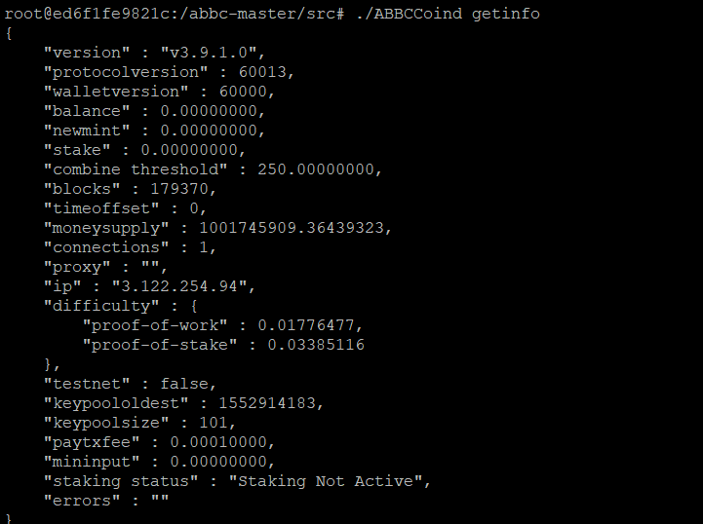

It means server is now running

Now Open Second Terminal

Then copy the ABBCCoind to /usr/local/bin folder

sudo docker cp [container id]:/abbc-master/src/ABBCCoind /usr/local/bin

then when you will check your /usr/local/bin directory you will get the ABBCCoind binary ..

then run

sudo docker build -f Dockerfile.run -t bitcoin-alpine-run .  
sudo docker run --rm -it -p 45251: 45251bitcoin-alpine-run

then you will see the ABBCCoind is in you’re your **/usr/local/bin directory**

run the ABBCCoind binrary

./ABBCCoind

Then copy the same ABBCCoin.conf file to /home/[server name]/.ABBCCoin folder

Or

RUN..

cp /home/ubuntu/abbc\_node\_new/ABBCCoin.conf /home/ubuntu/.ABBCCoin/

Then

Your server is get started

./ABBCCoind getinfo

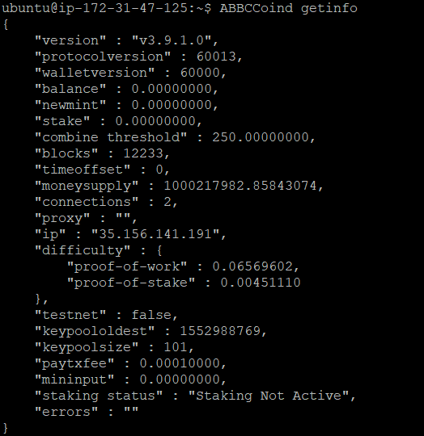

You should now see the usual output of the getinfo command similar to the test that we have done before directly in the container.

Then make Sure you have installed updated libs in you server

If not then try this commands

sudo apt-get install libdb5.3++-dev

sudo add-apt-repository ppa:boost-latest/ppa

sudo apt-get update

sudo apt-get install libboost-all-dev

sudo apt-get install libminiupnpc-dev